MARKING KEY 3CMAT/3DMAT
0000.doc
0000.doc

RESOURCE-FREE EXAMINATION

Question 1 [7 marks]
Given 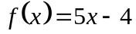,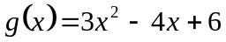 and 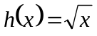 determine:
(a) 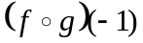

2 marks | Description
1 | 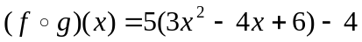  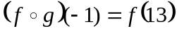✓
1 | 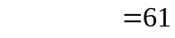✓

(b) 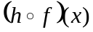

1 mark | Description
1 | 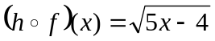✓

(c) the domain and range of:
(i) f

1 mark | Description
1 | Domain of f = ℜ, Range of f = ℜ ✓

(ii) h

1 mark | Description
1 | Domain of h = ℜ⁺∪{0}, Range of h = ℜ⁺∪{0} ✓

(iii) 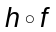

2 marks | Description
1 | Domain of 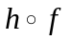 = {x : x ≥ , x ∈ℜ} ✓
1 | Range of = ℜ⁺∪{0} ✓

Question 2 [6 marks]
(a) Determine 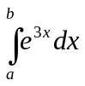
2 marks | Description
1 | 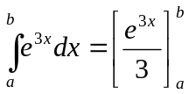 ✓
1 | 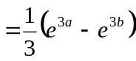 ✓

(b) Show that 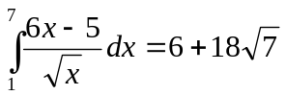

4 marks | Description
1 | 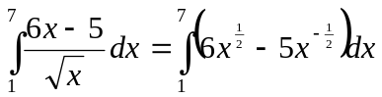 ✓
2 | 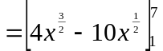 ✓✓
1 | 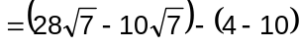 ✓  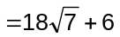

Question 3 [8 marks]
The curve 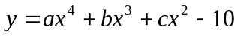 has a point of inflection at (-1,-1). The tangent to the curve at
x = -2 is parallel to the line 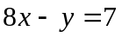. Find a, b and c by setting up a system of equations, then using an algebraic method to solve the system.

8 marks | Description
1 | 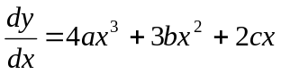✓
1 | 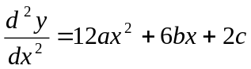✓
1 | 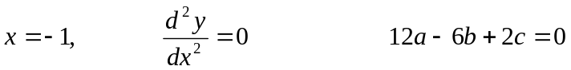 ① ✓
1 | ② ✓
1 | 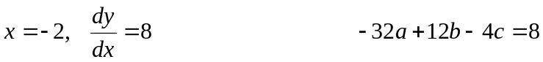 ③ ✓
1 | ① ÷ 2 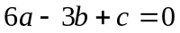   ③ ÷ 4 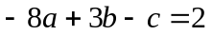    +  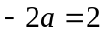  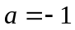 ✓
1 | ② -  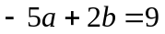   subst a = -1 in , b = 2 ✓
1 | subst a = -1, b = 2 in ② c = 12 ✓

Question 4 [7 marks]

(a) Simplify: 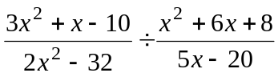

3 marks | Description
2 | 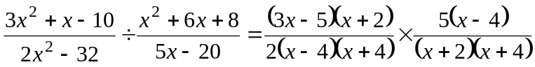 ✓✓
1 | 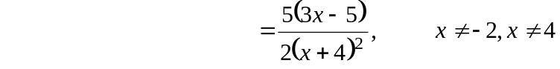 ✓

(b) Solve: 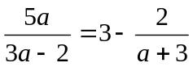

4 marks | Description
2 | ✓✓
1 | 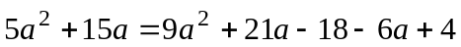 ✓  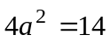
1 | 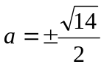✓

Question 5 [12 marks]
A window is to be made in the shape of a rectangle surmounted by a semi-circle. The radius of the semi-circular section is y cm, the length of the rectangular section is x cm and the perimeter of the window is L cm.

(a) Find L in terms of x and y. Hence show that 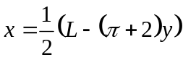 and deduce that 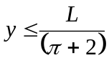.

3 marks | Description
1 | 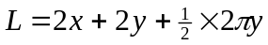✓  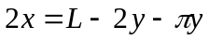  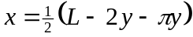
1 | 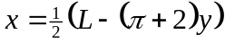 ✓
1 | but 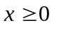  ∴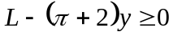  ∴✓

(b) Show that the area A cm² of the window is given by 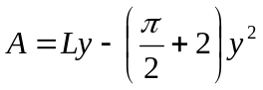

4 marks | Description
2 | 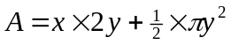✓✓
1 | 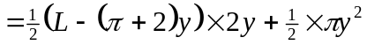✓
1 | 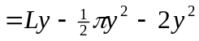  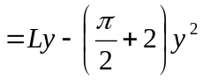 cm² ✓

(c) Show that, for a given L, the greatest possible area of the window is 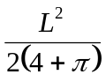

5 marks | Description
1 | 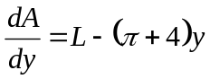 ✓
1 | and if 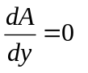then 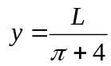 ✓ which is in the domain 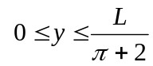
1 | and 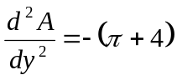 which is always negative ✓
1 | ∴ gives the relative and absolute maximum value of A  Hence,  maximum area = 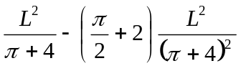 ✓
1 | 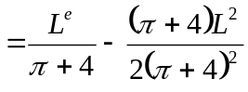  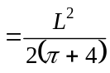 ✓

RESOURCE-RICH EXAMINATION

Question 1 [5 marks]
A student who was asked to prove the Alternate Segment Theorem gave this ‘proof’:

Since the Alternate Segment Theorem has to be true for all triangles, it has to be true when one side of the triangle is the diameter of the circle.

∠ABD = 90° (angle between a radius and a tangent)
∴ x = 90°
∠BCD = 90° (angle in a semicircle)
y = 90°
and x = y

(a) Discuss the validity of the student’s proof.

2 marks | Description
1  1 | The proof attempts to justify the general case from a particular case ✓  which is not valid. ✓

(b) The diagram below shows an isosceles triangle BED, its circumcircle and tangent at one vertex B. ∠ABD = x and ∠CBE = y.
Prove that 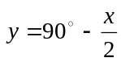
3 marks | Description
1 | To prove:  Proof:  ∠BDE = ∠CBE (alternate segment theorem)  ∴∠BDE = y ✓ geometric argument with reason
1 | ∠DBE = ∠BDE (base angles of an isosceles triangle)  ∴∠DBE = y ✓ geometric argument with reason
1 | ∠ABD + ∠DBE + ∠CBE = 180° (adjacent angles on a straight line)  ∴ x + y + y = 180°  ∴ y = 90° - x/2 ✓ geometric argument with reason  or  To prove:  Proof:  ∠BED = ∠ABD (alternate segment theorem)  ∴∠ BED = x  ∠BDE = ∠CBE (alternate segment theorem)  ∴∠BDE = y  ∠DBE = ∠BDE (base angles of an isosceles triangle)  ∴∠DBE = y  ∠DBE + ∠BED + ∠EDB = 180° (sum of the angles in a triangle)  ∴ y + x + + y = 180°  ∴ y = 90° - x/2  ✓✓✓ geometric argument with reasons (-1 mark each major step missing)  or other valid proof

Question 2 [6 marks]
Events A and B have these probabilities: P(A) = 0.45, P(B) = 0.52, P(A ∪ B) = 0.736

(a) Evaluate
(i) P(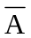)

1 mark | Description
1 | 1 – 0.45 = 0.55 ✓

(ii) Evaluate P(A ∩ B)

2 marks | Description
1 | Venn Diagram  or  P(A ∪ B) = P(A) + P(B) – P(A ∩ B) ✓
1 | ∴P(A ∩ B) = 0.45 + 0.52 – 0.736  = 0.234 ✓

(iii) Evaluate P(B|)

1 mark | Description
1 | P(B|) = 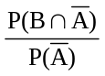  = 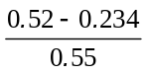  = 0.52 ✓

(b) Determine whether or not events A and B are independent.

2 marks | Description
1  1 | P(B|A) = 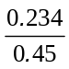 = 0.52 = P(B) ✓  ∴ A and B are independent ✓
or  1  1 | or  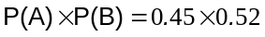= 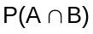 ✓  ∴ A and B are independent ✓
or  1 | or  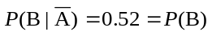 ✓
1 | ∴ A and B are independent ✓

Question 3 [7 marks]
An experiment involves rolling a fair die and when 6 is on the uppermost face the outcome is called a ‘success’. If the random variable X represents the number of successes when the die is rolled 48 times, calculate:

(a) the expected mean value for X

1 mark | Description
1 | μ = n p = 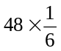 = 8 ✓

(b) the expected standard deviation for X.

1 mark | Description
1 | 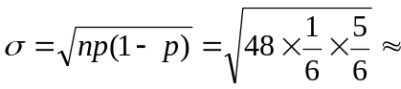 2.582 ✓

(c) As part of exploring the outcomes of the above experiment, Mr Brown asks each student in his class of 30 to roll a die 48 times. He records the number of successes for each student, and calculates the mean number of successes. The class repeats this exercise 10 times.

Sketch a graph showing the distribution that you would expect for the 10 mean values.

2 marks | Description
1  1 | Graph showing  - a normal distribution  - central value of 8 (mean of the means)  - standard deviation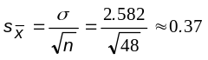. ✓✓two properties

(d) Ms Smith’s class of 15 students explores the same experiment—each student rolls a die 48 times, Ms Smith records the number of successes for each student and calculates the mean number of successes. Ms Smith’s class repeats the exercise 10 times.

Compare and contrast the distribution of mean values that you would expect for Ms Smith’s and Mr Brown’s classes.

3 marks | Description
1  1  1 | expect:  the same shaped distribution (normal) ✓  the same central value ✓  greater spread (standard deviation) for Ms Smith’s class than for Mr Brown’s✓

Question 4 [6 marks]
An object moves along a straight line for a period of k seconds. The graph of its velocity, v m/s, as a function of time, t seconds, is shown in the diagram.

Given, 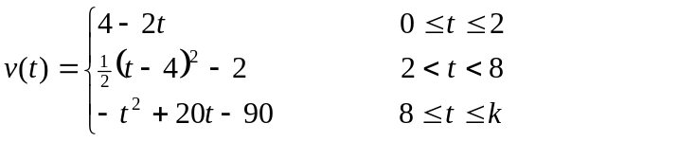
Determine:
(a) k

1 mark | Description
1 | 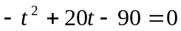 and 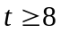  t = 13.16 (2 dp) ✓ (accuracy must be stated for the mark or the exact value 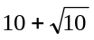 provided. Two solutions or the incorrect solution—zero marks)

(b) the distance travelled by the object in the first 8 seconds.

3 marks | Description
2 | 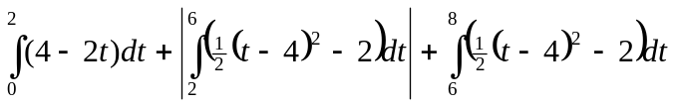 ✓✓ (-1 each error)
1 | = 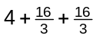  = 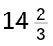 m ✓

(c) the time(s) at which the acceleration of the object is 0 m/s².

2 marks | Description
1 | 2 < t < 8, 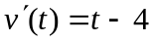  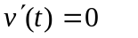 ∴ t = 4 ✓
1 | 8 < t < k, 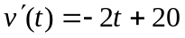  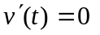 ∴ t = 10✓

Question 5 [6 marks]
A spherical metal ball of radius 4 cm is coated with a layer of ice of uniform thickness. The ice is melting such that when the ice is 6 cm thick, the thickness of the ice is decreasing at the rate of 0.008 cm/h.

When the ice is 6 cm thick, calculate the rate at which the volume of the ice is decreasing.

6 marks | Description
1 | Let thickness of ice be x cm and volume be V 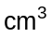.  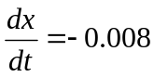 cm/h when x = 6 ✓
1 | 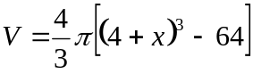 ✓
1 | 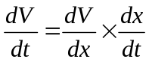 ✓
1 | 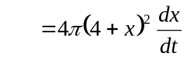✓
1 | when x = 6, 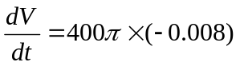/h ✓
1 | = - 3.2 π /h  = -10.053 /h to 3 dp  When the ice is 6 cm thick, the volume of the ice is decreasing at the rate of 3.2 π (or approx 10) /h ✓

Question 6 [7 marks]
The graph below shows the median monthly on-peak and off-peak energy consumption rates in kilowatts per month at an industrial site in the 1990s.

(a) Which month had the greatest median monthly on-peak energy consumption rate in the 1990s?

1 mark | Description
1 | February ✓

(b) Which two consecutive months produced the largest decrease in median monthly on-peak energy consumption rate in the 1990s?

1 mark | Description
1 | April and May ✓

Let t be the number of months since January.

The median monthly On-peak energy consumption rate in the 1990s 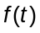can be modelled by
for 0 ≤ t ≤ 11.

The median monthly Off-Peak energy consumption rate in the 1990s 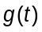 can be modelled by
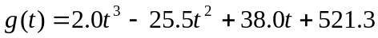 for 0 ≤ t ≤ 11.

(c) (i) Write an expression which would give the area between the graphs of 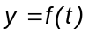 and 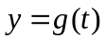 for 0 ≤ t ≤ 11.

2 marks | Description
1 | 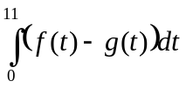 ✓
1 | = 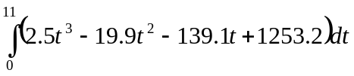 ✓

(ii) Find the area between the graphs of 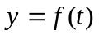 and 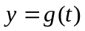 for 0 ≤ t ≤ 11.
Give your answer correct to five significant figures.

1 mark | Description
1 | 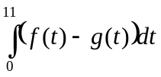= 5691.3 to 5 sf ✓

(iii) Interpret the area between the graphs of 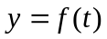 and 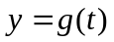 for 0 ≤ t ≤ 11.

2 marks | Description
1 | The area represents the difference in total consumption between On-peak and Off-Peak usage ✓
1 | in the 1990s. ✓

Question 7 [5 marks]
A workshop recorded the volume of oil removed from the most recent 120 cars serviced. The mean volume was 4.44 L and standard deviation 0.80 L. The lower quartile was 3.72 L, median 4.40 L, and upper quartile 5.12 L. Examine these statistics and make and justify a conclusion about whether or not the variable is normally distributed.

5 marks | Description
1 | Spread: for a normal distribution  P (X < upper quartile) = 0.75  hence, for the upper quartile, z = 0.6745 ✓
1 | and the upper quartile for a normal distribution with 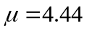and 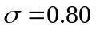  = 4.44 + 0.6745 × 0.8  ≈ 4.98 ✓ (calculator method without the z value sufficient if calculator function given)
1 | and the lower quartile  x = 4.44 - 0.6745 × 0.8  ≈ 3.90 ✓
2 | The actual quartiles (5.12L and 3.72L) differ quite a lot from the calculated values (about 18% of a standard deviation and 22% of a standard deviation) indicating the distribution is not normal.  or  The actual upper quartile is further from the mean and the actual lower quartile is closer to the mean than the calculated values, so the actual data is skewed (not symmetrical) about the mean, which indicates the distribution is not normal.  reasoning, ✓ conclusion ✓  (One reason why the distribution is not normal is sufficient)

Question 8 [5 marks]
A new drug is claimed to improve the hand–eye coordination of children. In order to test the drug, ten children who suffer hand–eye coordination difficulties participated in a six-week study. An appropriate study design was used which included measuring hand–eye coordination with a standard test.

The manager of the study recognises that improvement on a test could be due to the drug or due to chance alone and that the probability of any one child improving their score by chance alone is 0.5. Hence, the manager decides to accept that the drug improves hand–eye coordination only if the probability that the results could have been produced by chance alone is less than 10%.

(a) Use your knowledge of the binomial distribution to find the probability that eight or more children would show improvement by chance alone.

3 marks | Description
3 | ¹⁰C₈ × 0.5⁸ × 0.5² + ¹⁰C₉ × 0.5⁹ × 0.5¹ + ¹⁰C₁₀ × 0.5¹⁰ ≈ 0.05469 ✓✓✓

(b) If eight or more children show improvement, would the manager conclude that the drug improves hand–eye coordination? Explain.

2 marks | Description
1  1 | Yes, ✓  because the probability of improvement by chance is 5.4% which is less than 10% ✓

Question 9 [7 marks]
(a) Use algebra to show that the sum of five consecutive numbers is divisible by 5.

1 mark | Description
1 | x + (x + 1) + (x + 2) + (x + 3) + (x + 4) = 5x + 10 = 5(x + 2) which is divisible by 5 ✓

(b) Zaki continued to add consecutive numbers and summarised his results in a table:

On the basis of the results Zaki conjectured that:

The sum of n consecutive numbers
- is divisible by n for odd values of n and
- is not divisible by n for even values of n.

Zaki also recognised from the results that he could write a formula for ‘the sum of n consecutive numbers starting at x’.

He knew that 1, 3, 6, 10, 15, 21… are triangular numbers, T₁ = 1, T₂ = 3, T₃ = 6 …., and that the nth triangle number can be calculated using
T_{n} = 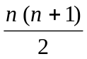

(i) Write a formula for ‘the sum of n consecutive numbers starting at x’.

2 marks | Description
2 | nx + T_{n –1} or nx + 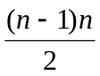 ✓✓

(ii) Using algebra and the formula that you wrote in (i) above, prove Zaki’s conjecture.

4 marks | Description
1 | The sum of n consecutive numbers is  nx +  = 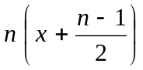 ✓
2 | which is divisible by n only if 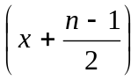 is a whole number ✓✓
1 | which occurs for odd values of n but not for even values of n ✓

Question 10 [12 marks]
The graph of 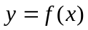, where 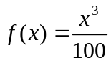, x > 0, is shown below.
The tangent to at x = 5 is also shown.
y
x
(a) Find 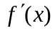.

1 mark | Description
1 | 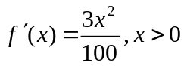 ✓

(b) Find the equation of the tangent to at x = 5.

3 marks | Description
1  1  1 | 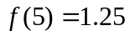✓  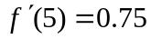 ✓  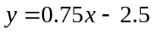 ✓ (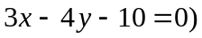

(c) The tangent to at x = 5 intersects the x-axis at E and the right-angled triangle CDE may be drawn, as shown in the diagram.
Find the exact length of ED.

2 marks | Description
1  1 | E has coordinates 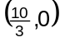 ✓  ED = 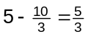✓

An infinite number of tangents to can be drawn. Each tangent forms a right-angled triangle CDE, where E is the x-axis intercept.

Jason investigates the tangents at x = 1, x = 3 and x = 12. His findings are summarised in the table below:

(d) (i) Using Jason’s findings, make a conjecture about the value of the length of ED for the tangent to at x = k in terms of k.

1 mark | Description
1 | The length of ED is 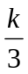 ✓

(ii) By considering the tangent at x = k, prove the conjecture you made in part (d)(i).

5 marks | Description
1 | 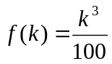 ✓
1 | 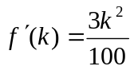 ✓
1 | Equation of tangent at x = k is 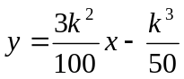 ✓
1 | E has coordinates 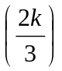 ✓
1 | ED = 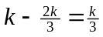 ✓

Question 11 [14 marks]
The golf balls purchased by the Seaviews Golf Club must meet a set of standards in order to be used in professional tournaments held at this golf club. One of these standards is the distance traveled. When a ball is hit by a mechanical device with a 10-degree angle of launch, a backspin of 42 revolutions per second, and a ball velocity of 72 metres per second, the distance the ball travels may not exceed 266.3 metres. Manufacturers want to develop balls that will travel as close to the 266.3 metres as possible without exceeding that distance.

A particular manufacturer that wishes to supply golf balls to the Seaviews Golf Club has determined that the distances traveled for the balls it produces are normally distributed with a standard deviation of 2.56 metres. This manufacturer has a new process that allows it to set the mean distance the ball will travel.

(a) If the manufacturer sets the mean distance traveled to be equal to 263 metres, what is the probability that a ball that is randomly selected for testing will travel too far?

2 marks | Description
1 | X: distance traveled, in m, by the golf balls  X ~ N(263,2.56) ✓
1 | P(X > 266.3) ≈ 0.0985 ✓

(b) Assume the mean distance traveled is 263 metres and that five balls are independently tested. What is the probability that at least one of the five balls will exceed the maximum distance of 266.3 metres?

2 marks | Description
1 | Y: number of balls exceeding 266.3m  Y ~ b(5, 0.0985) ✓
1 | P(Y ≥ 1) = 1 – P(Y = 0)  ≈ 1 – 0.9015⁵  ≈ 0.4046 ✓

(c) If the manufacturer wants to be 99 percent certain that a randomly selected ball will not exceed the maximum distance of 266.3 metres, what is the largest mean that can be used in the manufacturing process?

2 marks | Description
1  1 | X ~ N(m, 2.56)  P(X ≤ 266.3) = 0.99 ✓  m ≈ 260.3 m ✓

The Secretary of the Seaviews Golf Club visits the manufacturer and is assured that the mean distance traveled by their golf balls is 263 metres. He makes a random selection of 64 golf balls.

(d) If the sample mean is 262.8 metres, determine a 99% confidence interval for the mean distance traveled by the golf balls.

3 marks | Description
1 | Using 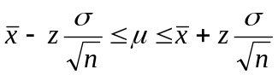 where z ≈ 2.58✓
1 | 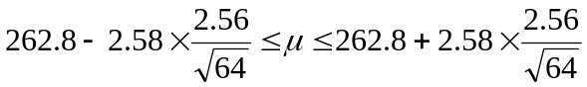 ✓
1 | 262.0 ≤ μ ≤ 263.6✓

(e) Determine the probability that the sample mean will lie between 262.5 metres and 263.5 metres.

3 marks | Description
1 | 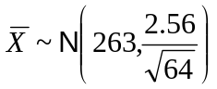 ✓
2 | P(262.5 ≤ 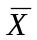 ≤ 263.5) ≈ 0.8812 ✓✓

(f) How large a sample should the manufacturer use to be 95 percent sure that the sample mean is within 1 metre of 263 metres?

2 marks | Description
1 | 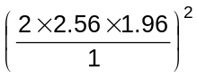 ✓ ≈ 100.7
1 | A sample of size 101 would be required. ✓

